FELICIA PHIRI
DATA ANALYTICS
31 MAY 2026
INRODUCTION AND OBJECTIVE:
Data Agent is an AI-powered assistant that can interact with data on behalf of a user. Instead of simply answering questions from its training data, a data agent can access databases, analyze information, run queries, generate reports, and provide insights.
The objective of the project is to build a working Data Agent on Databricks that answers business questions about a real retail sales dataset and write the agent's instructions.
Q1. Please show me sales by Gender
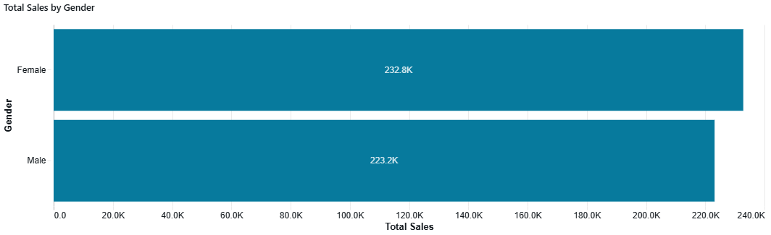

Q2. What are the lowest-performing products
Beauty is the lowest-performing product category with total revenue of 143,515, which is 8.4% below Clothing and 9.3% below Electronics
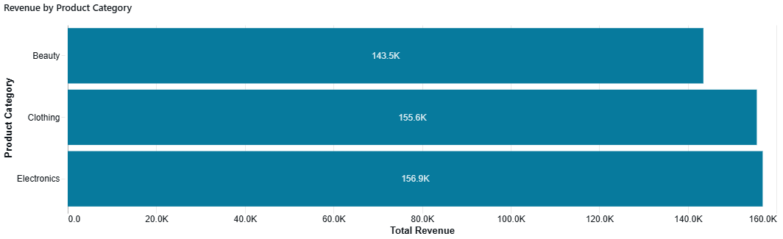
Q3.Which age group generates the most revenue

key Insights
The top three age groups (25-54 years) are nearly tied, each contributing approximately 97,000 in revenue and collectively representing 64% of total sales. However, the 18-24 age group shows the highest average transaction value at 501.01, suggesting younger customers spend more per purchase despite lower overall volume.4
The 45-54 group leads primarily due to higher transaction volume (225 transactions) rather than spending per transaction (432.16 average), which is actually the lowest among all age groups.

Q4. Monthly Sales Trends
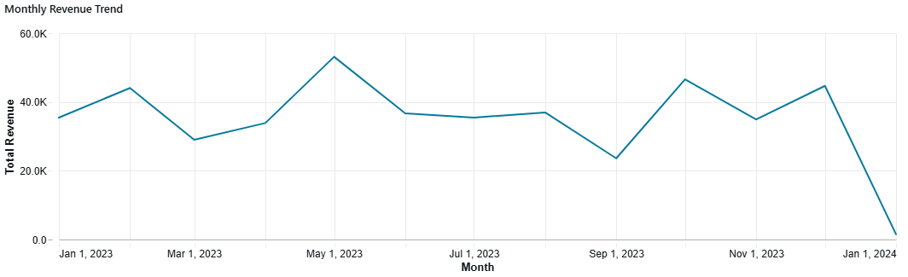

Key Patterns
Strongest months: May (53,150), October (46,580), and February (44,060) were the top three revenue months in 2023.5
Weakest month: September recorded the lowest revenue at 23,620, with only 65 transactions—a 56% drop from the May peak.5
Volatility: Revenue fluctuated significantly throughout 2023, ranging from 23,620 to 53,150. The average monthly revenue was approximately 38,000, with notable dips in March, April, and September.5
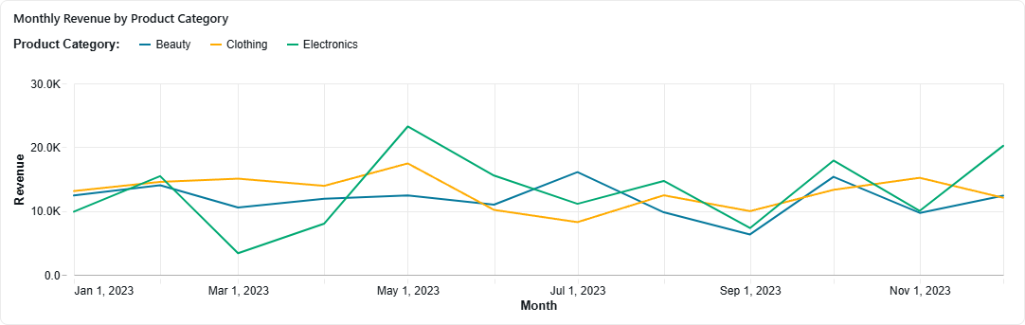

Q5. Which product category sells best for customers under 30.
Clothing is the top-performing category among customers under 30, generating 46,150 in revenue—11% more than Beauty and 30% more than Electronics.
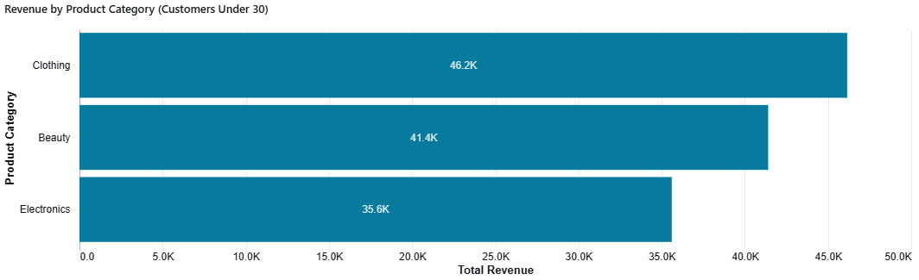

Q6. Compare sales between male and female customers
Female customers generate slightly higher sales than male customers
Female customers contributed 232,840 in total revenue compared to male customers at 223,160, representing a 4.3% difference.

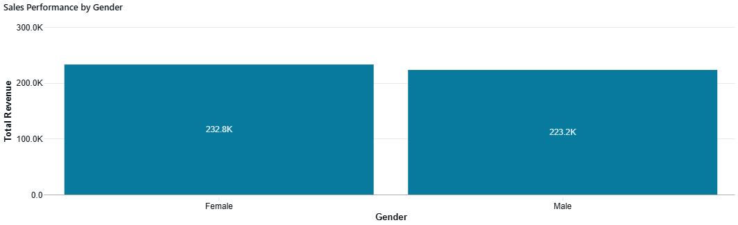
Female customers show marginally stronger performance across most metrics:
- Customer base: 510 female vs. 490 male customers (4% more)
- Transaction volume: 510 vs. 490 transactions
- Average transaction value: 456.55 vs. 455.43 (virtually identical)
- Units purchased: 1,298 vs. 1,216 units (6.7% more)

7.What were the best selling product category last quarter

Electronics was the best-selling product category in Q4 2023
Electronics led with 48,150 in revenue, outperforming Clothing (40,585) by 19% and Beauty (37,455) by 29%.
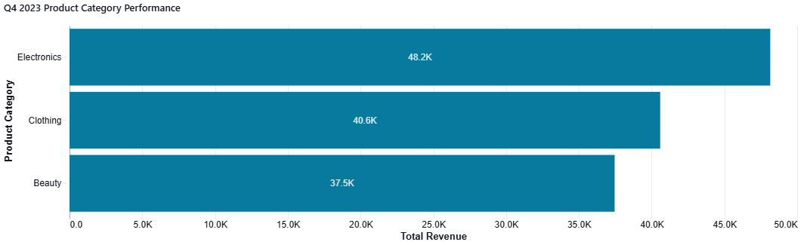
8. Who are the top 10 best customers.

Your top 10 customers each generated 2,000 in revenue from single high-value purchases
All ten top customers are tied at 2,000 in total revenue, each making exactly one transaction of 4 units.
9. Provide a summary of overall business performance.

Overall Business Performance Summary
The business generated 456,000 in total revenue from 1,000 transactions across 1,000 unique customers during the period from January 2023 to January 2024, with an average transa
Product Category Performance
All three product categories performed relatively evenly, with Electronics leading at 156,905 in revenue (34.4% of total), followed closely by Clothing at 155,580 (34.1%) and Beauty at 143,515
(31.5%). Electronics had 342 transactions with 849 units sold, while Clothing had the highest
transaction count at 351 with 894 units sold.ction value of 456.

10. Which product categories are purchased most frequently by males?
Clothing is the most frequently purchased product category by male customers, with 177 transactions (36.1% of all male purchases), followed closely by Electronics with 172 transactions (35.1%) and Beauty with 141 transactions (28.8%

